Gitlab Pipelining Linux (Ubuntu)

Requirement:

* + Pipeline Setup on ubuntu

# Gitlab-runner Installation:

<https://docs.gitlab.com/runner/install/>

* + Download the binary for your system

sudo curl -L --output /usr/local/bin/gitlab-runner https://gitlab-runner-downloads.s3.amazonaws.com/latest/binaries/gitlab-runner-linux-amd64

* + Give it permissions to execute

sudo chmod +x /usr/local/bin/gitlab-runner

* + Create a GitLab CI user

sudo useradd --comment 'GitLab Runner' --create-home gitlab-runner --shell /bin/bash

* + Install and run as service

sudo gitlab-runner install --user=gitlab-runner --working-directory=/home/gitlab-runner

sudo gitlab-runner start

# Register Gitlab-runner:

<https://www.youtube.com/watch?v=G8ZONHOTAQk>

or

sudo gitlab-runner register --url http://gitlab.webapp-dev.online/ --registration-token $REGISTRATION_TOKEN

# Connect Runner with gitlab repository:

Goto Repository settings

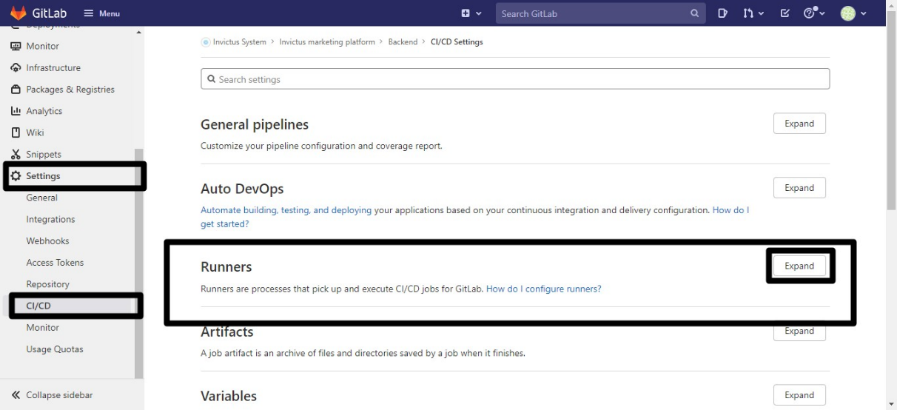

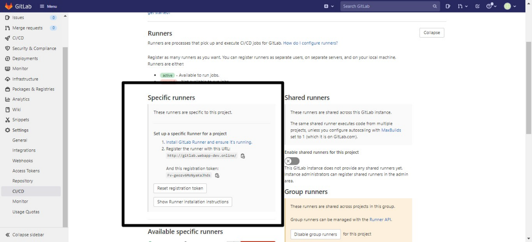

# SSH Key Add

* + Run command after changing user to gitlab-runner or on local user to create SSH key

$ ssh-keygen -t rsa -b 2048 -C "gitlab-runner"

* + To check if SSH is added

$ ssh -T [git@gitlab.webapp-dev.online](mailto:git@gitlab.webapp-dev.online)

Goto gitlab account preferenc/settings/ add ssh key there

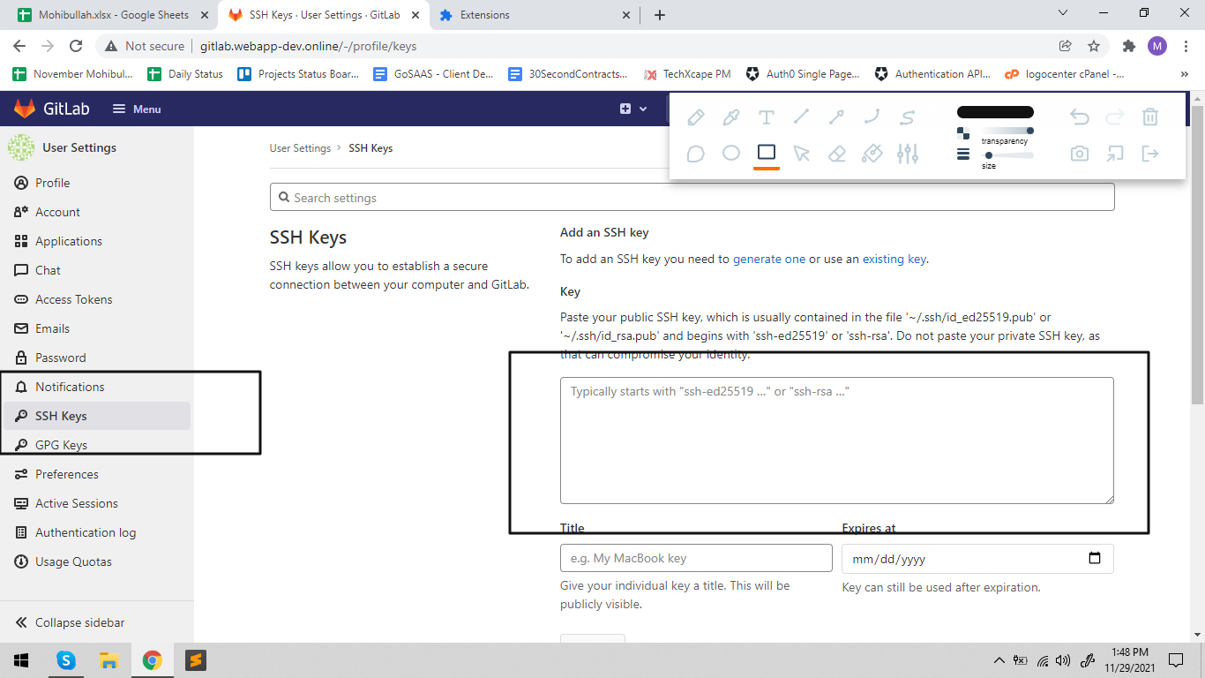

# Linux Comands

* + For listing user

$ cat /etc/passwd

$ less /etc/passwd

$ more /etc/passwd

$ runuser #username

# Gitlab-runner.Service file:

* + Create service file with this code

[Unit]

Description=GitLab Runner

ConditionFileIsExecutable=/usr/local/bin/gitlab-runner

After=syslog.target network.target

[Service]

StartLimitInterval=5

StartLimitBurst=10

ExecStart=/usr/local/bin/gitlab-runner "run" "--working-directory" "/home/gitlab-runner" "--config" "/etc/gitlab-runner/config.toml" "--service" "gitlab-runner" "--user" "gitlab-runner"

Restart=always

RestartSec=120

EnvironmentFile=-/etc/sysconfig/gitlab-runner

[Install]

WantedBy=multi-user.target

# Gitlab-runner Config file

* + Goto "/etc/gitlab-runner/config.toml copy this code

concurrent = 1

check_interval = 0

[session_server]

session_timeout = 1800